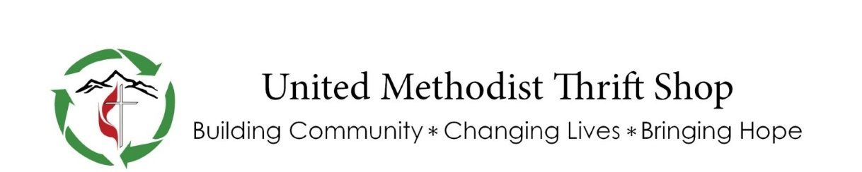
MTS Funding Request Application
The MTS was established in 1969 by the First United Methodist church to generate funds for capital improvements and construction. Over the years the MTS has expanded its mission to provide financial support to organizations throughout the community.
Please email this form to umtsfunding@gmail or mail/drop off in person to Georgia Stilwell, Methodist Thrift Shop, 986 East Second Avenue, Durango, CO 81301.
All one-time requests should be submitted by the first of the month on the following months: February, April, June, August, October and December. For larger annual funding requests ($5,000+) to be considered for the following year, the deadline is October 1st. If the requested amount is above $5,000, funding would be distributed in quarterly payments the following year.
DATE: __________________________
ORGANIZATION REQUESTING GRANT: ____________________________________________
501(c)(3) EIN: _________________________________________________________________
CONTACT PERSON: _____________________________________________________________
MAILING ADDRESS: _____________________________________________________________
PHONE: ____________________________ EMAIL: ___________________________________
PROJECT TITLE: _________________________________________________________________
TOTAL AMOUNT REQUESTED: ____________________________________________________
WHEN FUNDS ARE NEEDED: _____________________________________________________
WHO / WHAT IS BENEFICIARY OF GRANT: __________________________________________
HAVE YOU RECEIVED FUNDING FROM US IN THE PAST? IF SO WHAT YEAR(S) AND HOW MUCH DID YOU RECEIVE?
_______________________________________________________________________________
Please attach the following information:
1. Explanation of how funds will be used.
2. An itemized budget of funds requested.
3. Your most recent financial statements.
4. Timeline from start to completion of the project.
5. Other sources of funding for your project.
6. Copy of your 501(c)(3) letter.
If the MTS Lead Team chooses this organization/project as a recipient of one of our grants, we may request additional information. ***Grant applications will not be considered if not submitted by the deadline as outlined above.
Signature: ___________________________________ Date: __________________________
(Signature of Director or Project Manager)

